**Commodore PET IEEE-488 Extender Base Centronics Rev. 0**

**Module Description**

The IEEE-488 extender can serve multiple purposes:

1. Splitting the card edge IEEE-488 connector via a riser board (Project No. 170), so an additional device like a SD2PET future can be connected.
2. Adapting an IEEE-488 cable to the edge connector of the PET.

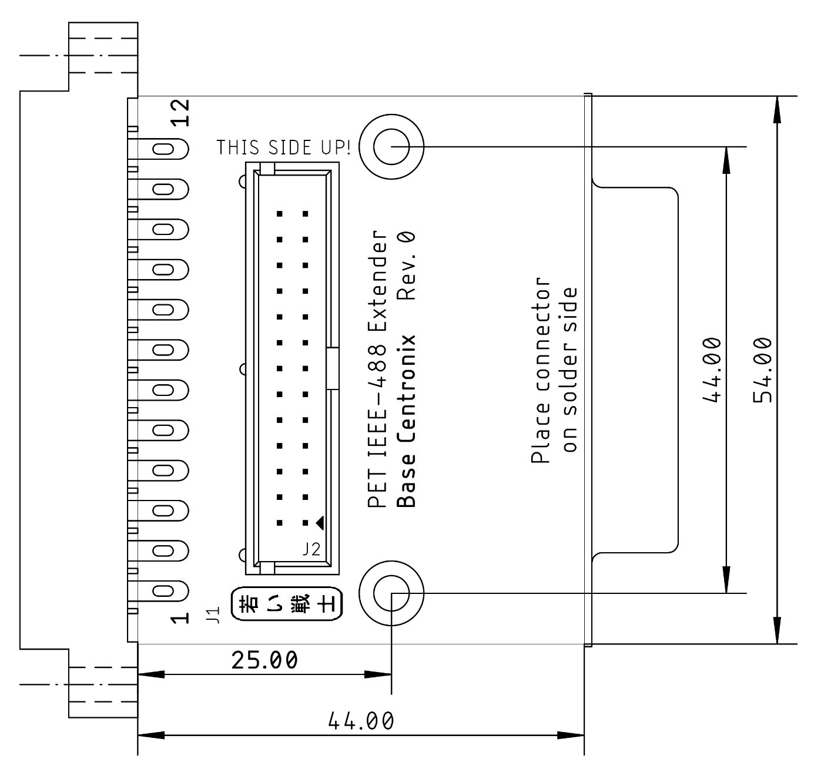

Figure 1: Dimensions of the IEEE-488 Extender

# 3D-Printed Case

Depending on the intended usage, there are different sorts of 3D cases/configurations. The 3D-printed case provides a good support for the extension board and the cable. If it is only intended to use the extension as an adapter for the Centronics type (=standard) IEEE-488 cables, the top shell can be installed (J2 cannot be assembled in this case). The height above the desktop of the PET is different than that of the Tynemouth Software/TFW8bit miniPET. The miniPET adapter case is 2mm higher.

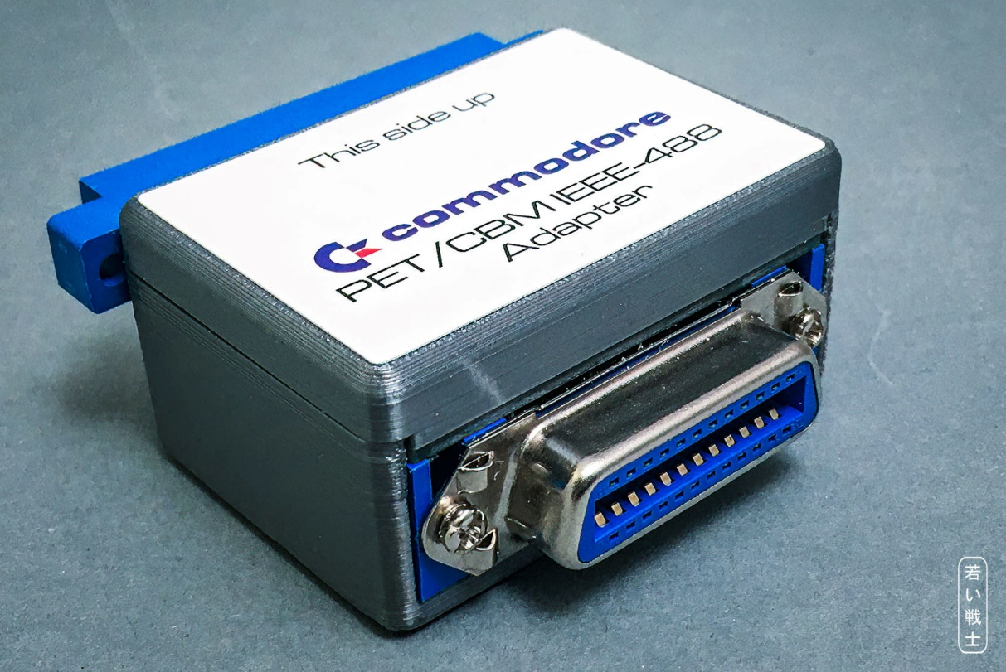

Figure 2: Full 3D printed case

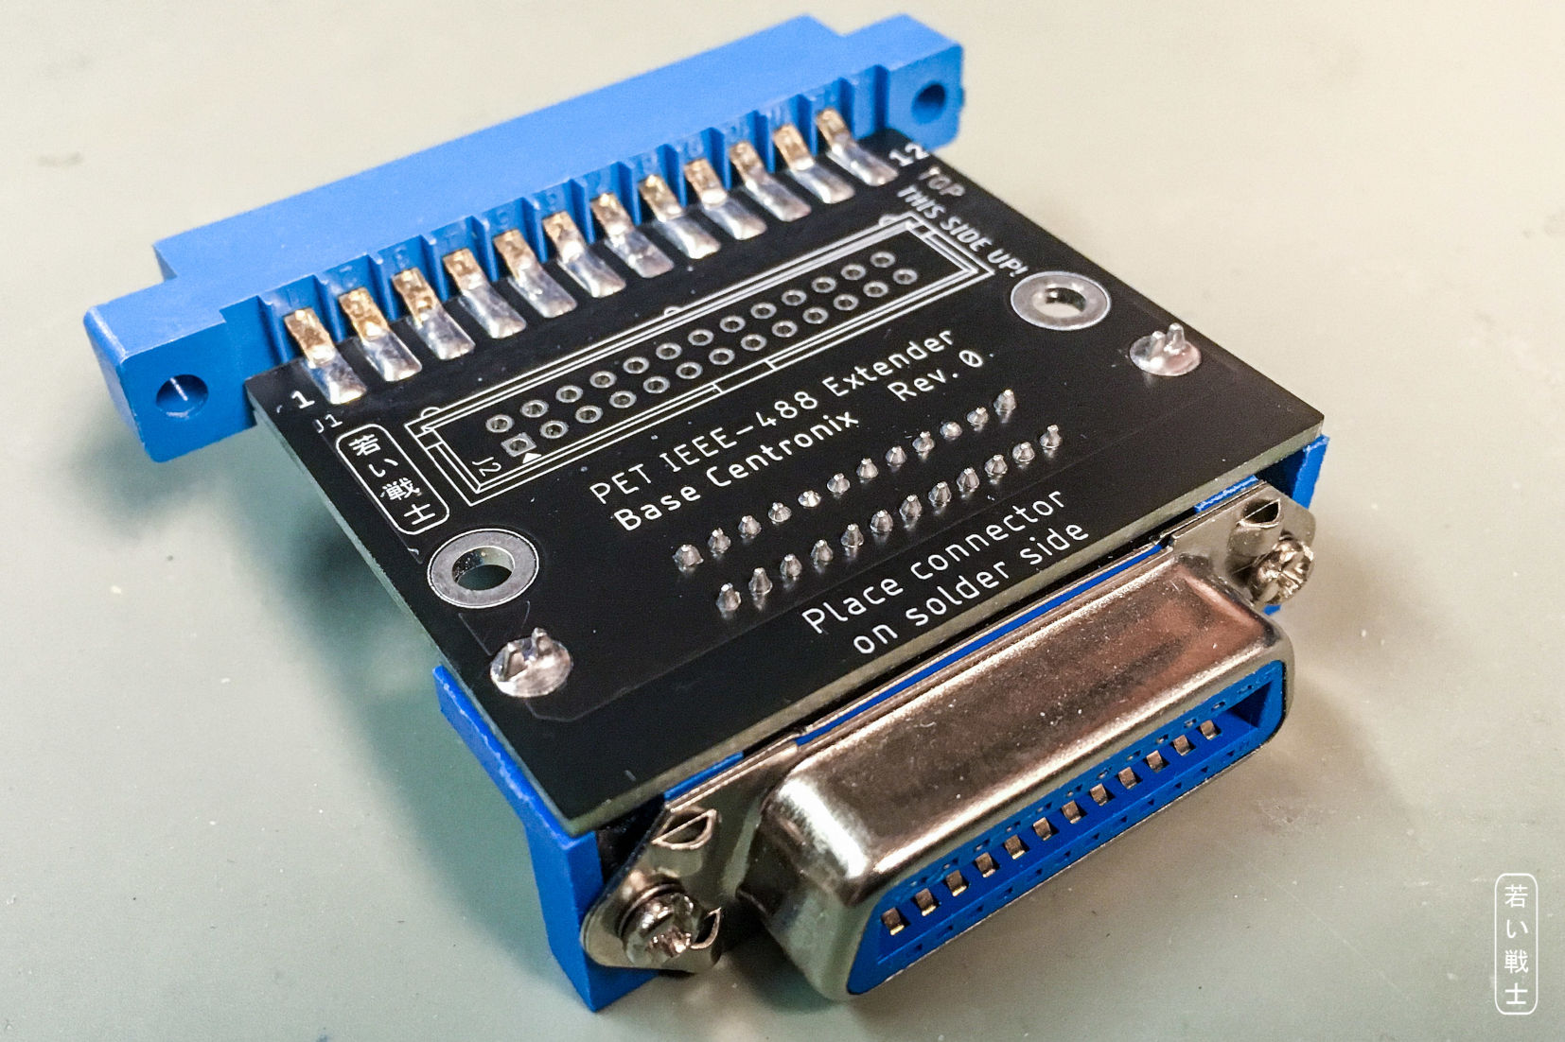

Figure 3: Centronics Base without J2

Figure 3 shows the Centronics Base without J2 to allow the top shell of the case to be installed.

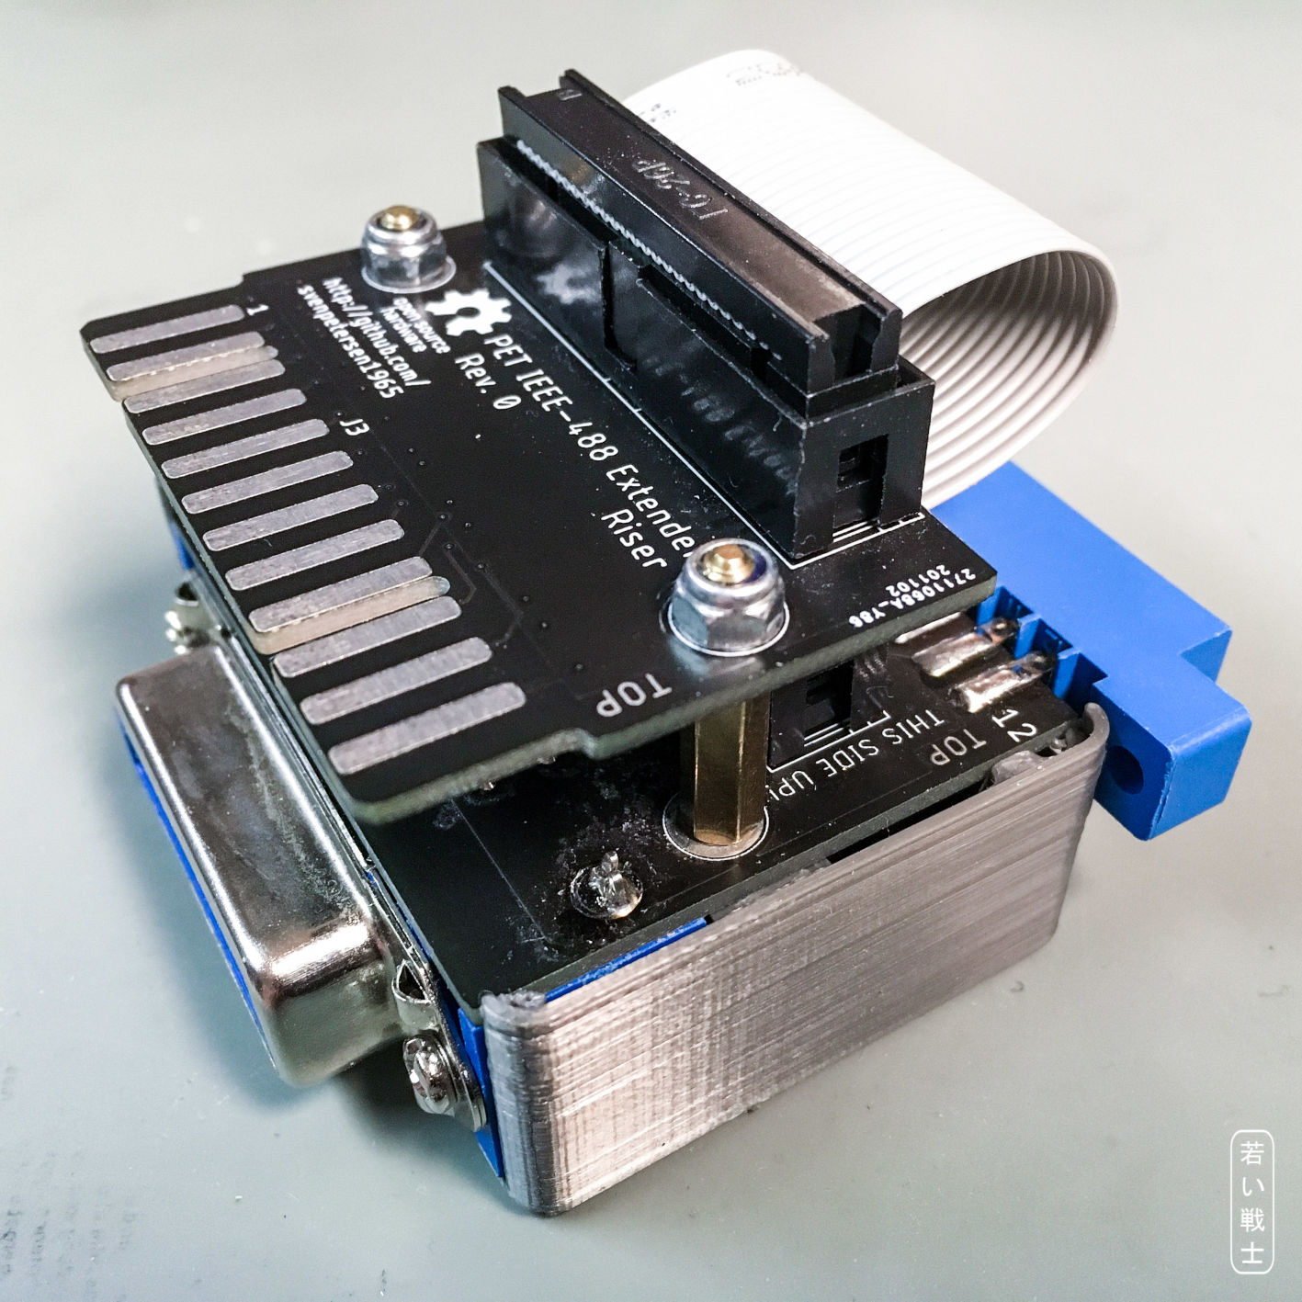

Figure 4: Centronics Base with Riser and the bottom shell installed only

# Connectors

**J1** is a female card edge connector, that connects to the PET/CBM Mainboard, **J3** is a 24p. female Centronics connector (fits IEEE-488) (Ali Express “Series 57”), which connects to the IEEE-488 peripherals via an IEEE-488 cable. **J2** is a 2x13 pin header/box connector.

|  |  |  |  |  |  |  |  |
| --- | --- | --- | --- | --- | --- | --- | --- |
| J1 | J3 | Signal | J2 | J2 | Signal | J3 | J1 |
| 1 | 1 | DIO1 | 1 | 2 | DIO5 | 13 | A |
| 2 | 2 | DIO2 | 3 | 4 | DIO6 | 14 | B |
| 3 | 3 | DIO3 | 5 | 6 | DIO7 | 15 | C |
| 4 | 4 | DIO4 | 7 | 8 | DIO8 | 16 | D |
| 5 | 5 | EOI | 9 | 10 | REN | 17 | E |
| 6 | 6 | DAV | 11 | 12 | GND | 18 | F |
| 7 | 7 | NRFD | 13 | 14 | GND | 19 | H |
| 8 | 8 | NDAC | 15 | 16 | GND | 20 | J |
| 9 | 9 | IFC | 17 | 18 | GND | 21 | K |
| 10 | 10 | SRQ | 19 | 20 | GND | 22 | L |
| 11 | 11 | ATN | 21 | 22 | GND | 23 | M |
| 12 | 12 | GND | 23 | 24 | GND | 24 | N |
| - | - | GND | 25 | 26 | GND | - | - |

Table 1: IEEE-488 signal pinouts

The shield of J3 is connected to GND.

# SD2PET future Splitter

The SD2PET future has an edge connector IEEE-488 interface, which does not allow to connect any other IEEE-488 peripheral. It might be desired to do so, though. In this case, the SD2PET future has to drive both, the PET and the peripheral bus load. The maximum load is not defined.

The configuration was tested with a CBM8032 and a CBM8050 floppy disk drive attached via a 1.5 meter long IEEE-488 cable. The CBM8050 has to be set (via hardware) to a **device address** other than 8, since this is the default address of the SD2PET future. It is not possible to switch off the CBM8050 and reconfigure the device address of the SD2PET.

Using the SD2PET future and a printer was not tested, but very likely works, since the interface circuitry is similar to the CBM8050.

The bus splitting requires the riser board, like shown in Figure 4.

# Revision History

## Rev. 0

* Prototype (fully functional)